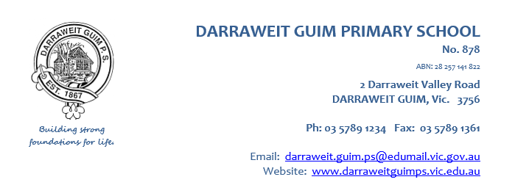

Dear Parent/Carer/Guardian,

Darraweit Guim PS is looking forward to another great year of teaching and learning and would like to advise you of our proposed financial contributions for 2026. Schools provide students with free instruction to fulfil the standard curriculum requirements, and we want to assure you that all contributions are voluntary.

We want to thank you for all your support, whether that is through fundraising or volunteering your time. This has made a huge difference to our school and the programs we can offer.

For further information on the Department’s Parent Payments Policy please see a one-page overview attached.

Yours sincerely,
Carol Booker Alysha Haine
Principal School Council President
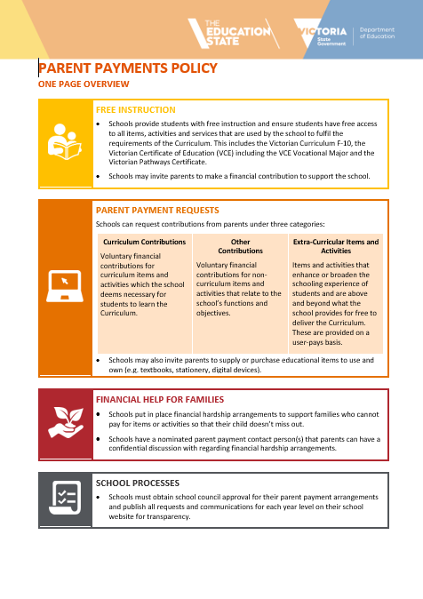

Curriculum Contributions - items and activities that students use, or participate in, to access the Curriculum | Amount
Classroom consumables, materials & equipment  For example:  - Art – paint, crayons, canvas, glitter, coloured paper  - STEM – magnets, tape, safety gear, string, balloons, vinegar  - Mathematics – concrete materials such as counters, dice, graph paper, flipcharts, number lines  - English – highlighters, whiteboards, lined paper, sticky notes  - Sports – equipment  - Photocopy paper  - Classroom coloured paper  - Kitchen-Garden – ingredients for cooking | $85
Online subscriptions  - Essential Assessments  - Mappen | $15
ICT devices – provision of devices from the shared classroom sets | $20
Printing and photocopying of worksheets and learning materials, toner, copy charges | $20
Other Contributions - for non-curriculum items and activities | Amount
First aid equipment | $10
School grounds maintenance and improvements | $20

Classroom Stationery
Years 2-6
Parents/Carers/Guardians will be asked to supply stationery for their child/ren.
- A stationery list can be obtained from the administration office

Extra-Curricular Items and Activities | Amount
Incursions/Excursions, School camp, Sports program etc | Payments are determined and due at the time of the activity.  - Where possible, parents will be given 4 weeks’ notice prior to payment due date.

Category | Totals
Curriculum Contributions | $140
Other Contributions – for non-curriculum items and activities | $30
Total | $170

Financial Support for Families
Darraweit Guim PS understands that some families may experience financial difficulty and offers a range of support options, including:
- the Camps, Sports and Excursions Fund
- State Schools Relief (SSR)
- Payment plans for Extra-Curricular Items and Activities

Payment Methods
If you would like to arrange a payment plan or monitor your payments, please contact Kirsty Steven or Carol Booker. We would be pleased to assist you.”

BANK PAYMENT DETAILS
BSB: 063-093
Account No: 10000570

